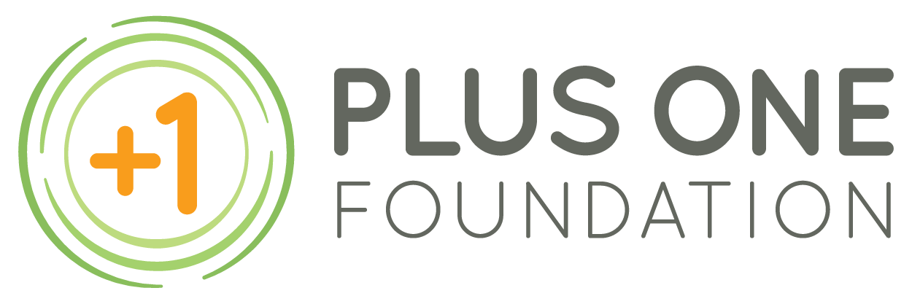

APPLICATION FOR ONE GRANT
Please complete the following information to apply for our ONE Program. Submitting an application does not guarantee acceptance. Please attach the Diagnosis Form completed by a physician. Your application will not be complete without the Diagnosis Form. If you need a volunteer to assist you with this application process, please connect with us via plus1foundation1@gmail.com or call 206-285-0628 and a volunteer will get back to you.
APPLICANT INFORMATION
First Name: ______________________________ Last Name: _____________________________ Birthday: __________
Address: __________________________________ City: _____________ State: _____ Zip Code: __________
Diagnosis (must be a neurological injury, disease or disorder)________________________________________
Required: Attach Diagnosis Form
Check and complete your preferred method of communication:
Telephone: _____________________ Alternate Phone: ____________________
E-mail: ___________________________________________  Other: _______________________
Some applicants find it helpful to have someone assist them in the application process. Is there someone who is currently assisting you that should receive the same communications we send to you?
Name: _________________________ Email: _______________________ Phone: ____________________
(Please be sure to inform this person ahead of time that they will be receiving information from us)
How did you hear about the Plus One Foundation ONE Program? __________________________________________________________________________________________
Please tell us about why you are applying to the ONE Program. Describe the experience you believe will assist you in your rehabilitation, education or re-education as related to your diagnosis and explain why this is so important to you. Describe what you believe you will gain from this experience. Please provide as much detail as possible. If you have a specific service or location in mind, please explain in detail why you have selected it. (Please attach your narrative as additional pages).
Do you have the financial means to pay for this experience? (circle one) YES NO
Are you an immediate family member (spouse/partner or son or daughter) of someone who serves as a Plus One Foundation Board of Director, staff, volunteer or donor? (circle one) YES NO
It is our policy that no immediate family members may receive grants, distributions or services from the Plus One Foundation.

If you have a legal guardian or are under the age of 18, please have your guardian fill out the following and sign below.
Legal Guardian’s First Name: _____________________ Last Name: _________________________________
Address: ___________________________________ City: ___________ State: _____Zip Code: ____________
Phone: ____________________________ E-mail: _______________________________________________

I hereby certify that the information on this form in its entirety is true and correct to the best of my knowledge.

X___________________________________________________________________________
APPLICANT’S SIGNATURE DATE
X___________________________________________________________________________
LEGAL GUARDIAN’S SIGNATURE DATE
(Legal guardian signature required only if applicant has a legal guardian or is under the age of 18)

Please mail this application (with Diagnosis Form) to:
Plus One Foundation
3213 W. Wheeler St, #372
Seattle, WA 98199
206-285-0628

